**POC**

**PyTorch Image Classification:**

Using CNN, CIFAR-10 trained ML model

Version 1.1.1

**BMV SYSTEM INTEGRATION PRIVATE LIMITED**

**Idea... Implementation... Innovation...**

**:: CORPORATE HEAD OFFICE ::**

**A503, The First,**

**Behind The ITC Narmada Hotel & Keshavbaug Party Plot,**

**Off 132 ft Road, Vastrapur, Ahmedabad.**

**Gujarat- 380015**

**Phone: +91 (79) 40 30 53 02**

**Website:** [**www.systemintegration.in**](http://www.systemintegration.in)

**Mail: info@systemintegration.in**

Table of Content

1. **Introduction**
2. **Deep Learning Overview**
3. **Convolutional Neural Network (CNN)**
   * + Architecture
     + Layers
     + Loss Function
     + Optimizations
4. **PyTorch Framework**
   * + Overview
     + Key Features
     + Inbuilt Functions
5. **Project Overview**
   * + Dataset: CIFAR-10
     + Model Training
       1. Training Steps
       2. Training Results
     + Model Testing
       1. Testing Steps
       2. Testing Results
6. **How to Improve Accuracy**
7. **Use Cases**
8. **Advantages**
9. **Limitations**
10. **Conclusion**

# **PyToch Image Classification**

## **1.** **Introduction**

This documentation provides a comprehensive overview of a project aimed at building a deep-learning model to classify images from the CIFAR-10 dataset. The model uses a Convolutional Neural Network (CNN) and achieves an accuracy of 89.41%. We will explore the fundamentals of deep learning and CNNs, the steps taken to train and test the model, and the results achieved. Additionally, the document covers the practical applications, benefits, and limitations of the model. The project is implemented using PyTorch, a popular deep-learning framework.

## **2. Deep Learning Overview**

Deep learning is a branch of machine learning where computers learn to perform tasks by studying large amounts of data. Instead of following explicit instructions, these systems use neural networks that mimic the human brain to recognize patterns and make decisions. This approach is particularly effective for complex tasks like image and speech recognition.

In deep learning, the neural network consists of multiple layers, each transforming the input data into increasingly abstract representations. This hierarchy of layers enables the network to learn features directly from the data, such as detecting edges in an image or understanding the context of a word in a sentence.

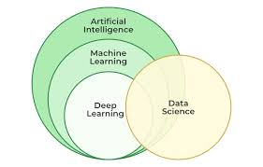

## **3. Convolutional Neural Networks (CNN)**

### **Architecture**

A Convolutional Neural Network (CNN) is a specialized type of neural network designed for processing structured grid data like images. CNNs are highly effective for image recognition and classification due to their ability to automatically and adaptively learn spatial hierarchies of features.

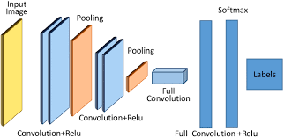

### **Layers**

* **Convolutional Layer**: This layer applies filters to the input image, creating feature maps that highlight various aspects of the data such as edges, textures, and patterns.
* **Pooling Layer**: This layer reduces the dimensionality of the feature maps by summarizing regions, which helps in reducing the computational load and mitigating overfitting.
* **Fully Connected Layer**: Each neuron in this layer is connected to every neuron in the previous layer, typically used towards the end of the network for making predictions based on the features learned by the convolutional and pooling layers.

### **Loss Function**

The loss function measures the difference between the predicted outputs and the actual labels. For classification tasks, the Cross-Entropy Loss is commonly used. It quantifies how well the model's predictions match the true distribution of the data.

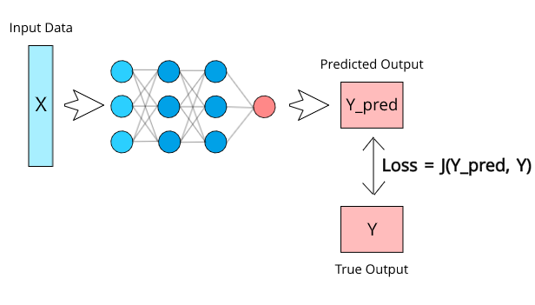

### **Optimizations**

Optimizers such as Stochastic Gradient Descent (SGD) and Adam are used to update the model parameters based on the gradients computed during backpropagation. These optimizers help in minimizing the loss function, thereby improving the model's performance.

## **4. PyTorch Framework**

### **Overview**

PyTorch is an open-source deep learning framework developed by Facebook's AI Research lab. It is widely used for building and training neural networks due to its flexibility and ease of use. PyTorch provides a dynamic computational graph, which means the graph is built on the fly as operations are performed, making it intuitive and easy to debug.

### **Key Features**

* **Dynamic Computational Graphs**: PyTorch's dynamic nature allows for flexible and efficient model building and modification.
* **Easy to Use**: With a Pythonic approach, PyTorch is straightforward for those familiar with Python, making it accessible to both beginners and experienced researchers.
* **Extensive Libraries**: PyTorch has a rich ecosystem of libraries and tools for computer vision, natural language processing, and more, enabling rapid development and experimentation.
* **Community and Support**: A strong community and extensive documentation help users troubleshoot and optimize their models.

### **Inbuilt Functions**

* **Dataset**: The Dataset class in PyTorch provides a way to handle and preprocess data efficiently. It is an abstraction that allows users to load data and apply transformations to it, facilitating easy integration with data loaders.
* **DataLoader**: The DataLoader class enables easy and efficient data batching, shuffling, and loading. It is essential to feed data to the model during training and evaluation in a streamlined manner.
* **nn.Linear**: This module applies a linear transformation to the input data, effectively functioning as a fully connected layer in the neural network. It is used to connect neurons between different layers.
* **Optimizer**: PyTorch provides various optimizers like SGD and Adam to adjust model parameters based on computed gradients. Optimizers help minimize the loss function and improve model performance.
* **loss.backward()**: This function computes the gradient of the loss concerning the model parameters using backpropagation. It is a crucial step in the optimization process.
* **Loss Function**: PyTorch offers various loss functions, with Cross-Entropy Loss being commonly used for classification tasks. It measures the discrepancy between predicted probabilities and true class labels.
* **zero_grad**: This function clears old gradients, ensuring that gradient computations in each iteration are not influenced by previous calculations. It is typically called before the backward pass.
* **Activation Function - ReLU**: The Rectified Linear Unit (ReLU) activation function introduces non-linearity into the model, helping it learn complex patterns. It sets all negative values to zero while keeping positive values unchanged.
* **Cross Entropy**: Cross-entropy loss combines LogSoftmax and Negative Log Likelihood Loss in one single class. It is used for multi-class classification problems.
* **Softmax Function**: This function converts raw model outputs (logits) into probabilities by normalizing the values, making them sum up to one. It is often used in the output layer of classification models.
* **Max-Pooling**: This operation reduces the spatial dimensions of the feature maps by taking the maximum value within a specified window. It helps in down-sampling the data and reducing computational load.

## **5. Project Overview**

### **Dataset: CIFAR-10**

The CIFAR-10 dataset consists of 60,000 32x32 color images divided into 10 classes, with 6,000 images per class. The classes are: 'plane', 'car', 'bird', 'cat', 'deer', 'dog', 'frog', 'horse', 'ship', and 'truck'. This dataset is widely used for training machine learning and computer vision algorithms.

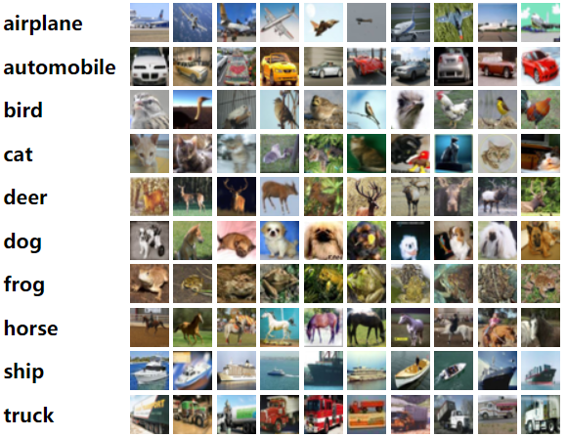

### **Model Training**

#### **Training Steps**

1. **Generate Random Images**: Load and preprocess the CIFAR-10 dataset to prepare it for training.

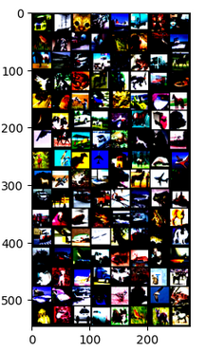

1. **Calculate Loss**: Compute the loss between the predicted and actual labels using Cross-Entropy Loss.
2. **Compute Gradients**: Perform backpropagation to calculate the gradients of the loss concerning the model parameters.
3. **Update Parameters**: Adjust the model parameters using an optimizer (e.g., SGD or Adam) based on the computed gradients.
4. **Reset Gradients**: Clear gradients to prepare for the next iteration of training.

The model is trained for 80 epochs, achieving the following performance:

* Validation Loss: 0.3354
* Validation Accuracy: 89.41%

#### **Training Results**

* Overall Accuracy: 89.41%
* Class-wise Accuracy:
  + Plane: 91.40%
  + Car: 94.90%
  + Bird: 85.20%
  + Cat: 79.00%
  + Deer: 89.50%
  + Dog: 82.30%
  + Frog: 92.00%
  + Horse: 91.60%
  + Ship: 94.10%
  + Truck: 94.10%

### **Model Testing**

#### **Testing Steps**

1. **Get a Random Image from Dataset**: Select an image from the CIFAR-10 dataset.

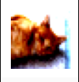

1. **Test the Image**: Preprocess the image and feed it into the trained model.
2. **Model Predicts the Image Class**: The model outputs the predicted class.

#### **Testing Results**

Example output:

* Predicted class: Cat
* Actual class: Cat

## **6. How to Improve Model Accuracy**

To further enhance the accuracy of the deep learning model, several strategies can be employed:

### **Increase the Number of Epochs**

Training the model for more epochs can help it learn better from the data, provided that overfitting is controlled. More epochs allow the model to refine its understanding of the training data.

### **Change Optimizer**

Experimenting with different optimizers, such as Adam, RMSprop, or AdaGrad, can lead to better convergence and improved accuracy. Each optimizer has its own way of adjusting learning rates and handling gradients.

### **Add More Hidden Layers**

Increasing the number of hidden layers in the network can help the model learn more complex patterns. However, this also increases the computational cost and the risk of overfitting.

### **Increase the Number of Filters**

Adding more filters in the convolutional layers can help the model capture more detailed features from the images. This generally improves the model's ability to generalize from the training data.

### **Adjust Batch Size and Learning Rate**

* **Batch Size**: Smaller batch sizes can lead to noisier gradient estimates but can help the model escape local minima. Larger batch sizes provide more stable gradient estimates.
* **Learning Rate**: Fine-tuning the learning rate can significantly impact the training process. A learning rate that is too high can cause the model to converge too quickly to a suboptimal solution, while a learning rate that is too low can make the training process excessively slow.

### **Add Padding and Stride**

* **Padding**: Adding padding to the input images can help preserve the spatial dimensions and ensure the filters are applied to the entire image.
* **Stride**: Adjusting the stride can control the overlap of the receptive fields and the spatial resolution of the feature maps. Smaller strides can capture more details, while larger strides reduce the spatial resolution.

## **7. Use Cases**

Deep learning models, particularly CNNs, have a wide range of applications due to their ability to effectively process and analyze visual data. Here are some common use cases:

* **Image Recognition**: Used in various applications such as facial recognition systems, identifying objects in images for autonomous vehicles, and more.
* **Medical Imaging**: Assisting in diagnosing diseases by analyzing medical images such as X-rays, MRIs, and CT scans.
* **Security and Surveillance**: Enhancing security systems by recognizing and tracking individuals or objects in video feeds.
* **Retail and E-commerce**: Improving customer experience by recommending products based on images, such as clothing or home decor items.
* **Content Moderation**: Automatically detecting and filtering inappropriate or harmful content on social media platforms.

## **8. Advantages**

* **High Accuracy**: Deep learning models, especially CNNs, can achieve high accuracy in image classification tasks due to their ability to learn complex patterns from data.
* **Automatic Feature Extraction**: Unlike traditional machine learning models, CNNs do not require manual feature engineering. They automatically extract relevant features from raw data.
* **Scalability**: Deep learning models can be scaled to handle large datasets and complex architectures, making them suitable for a variety of applications.
* **Versatility**: CNNs can be applied to a wide range of problems, from image and video recognition to natural language processing and beyond.

## **9. Limitations**

* **Computational Resources**: Training deep learning models, especially large CNNs, requires significant computational resources, including powerful GPUs and large amounts of memory.
* **Data Requirements**: Deep learning models typically require large amounts of labeled data for training, which can be expensive and time-consuming to obtain.
* **Interpretability**: The decision-making process of deep learning models is often seen as a "black box," making it difficult to interpret and understand how they arrive at specific predictions.
* **Overfitting**: Deep learning models can easily overfit the training data if not properly regularized, leading to poor generalization on new, unseen data.
* **Complexity**: Designing and tuning deep learning models can be complex and require expertise in machine learning and neural networks.

## **10. Conclusion**

This documentation provided an in-depth look at a project for image classification using a deep learning model trained on the CIFAR-10 dataset. By leveraging a Convolutional Neural Network (CNN) implemented in PyTorch, the model achieved an accuracy of 89.41%. We explored the fundamentals of deep learning and CNNs, discussed the steps for training and testing the model, and suggested various strategies for improving accuracy. The practical applications, benefits, and limitations of the model were also covered, demonstrating the potential and challenges of deep learning in image classification tasks.